Name ______________________________________ Date _______________ Class _____
Unit 4 Study Guide PREAP
Vocabulary – Put The Definition in Your Own Words
Use your knowledge of Social Studies, a dictionary, the internet, or your notes to complete.

1. Import

2. Export

3. Colonize

4. Controversy

5. Conquistador

Each February, Brazilians celebrate a four-day holiday. The festival is held 40-55 days before Easter usually during the last week of Lent. Millions of working-class and middle-class Brazilians spend much of the year preparing for it by making costumes and building parade floats. Rio de Janeiro’s Carnival is the largest and is world famous.

6. The above passage is referencing which holiday? _______________________________
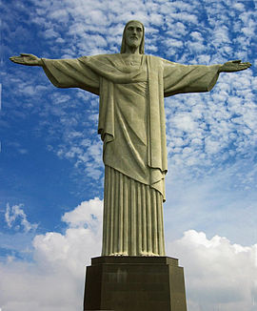
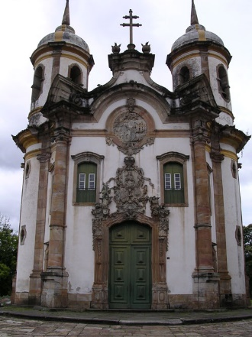

7. Based on the pictures above, what is the dominant religion practiced in S. American countries. _________________________________________________________________________
8. Name a popular sport that is played in the region. ______________________________

Use the picture below to answer Q9
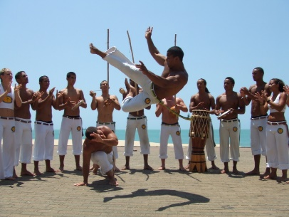

9. Copoeira is a martial art that combines elements of _____________________________ and __________________________.
The Galapagos Islands lie in the Pacific, about 600 miles west of Ecuador. They consist of 13 major islands, six smaller ones, and may tiny islands called islets. These rocky islands, which were formed by underwater volcanoes, are owned by Ecuador. Most have no human population.

The islands’ isolation makes them home to many unusual animals, such as lizards that swim and birds with wings although they do not fly. In the 1800s, British scientist Charles Darwin studied the islands’ animals to develop his theory of evolution. Today, the islands are tourist attractions. Many are protected as national parks.

10. Based on the above article, isolation contributes to all of the following except –
- Low population density
- Charles’ Darwin’s theory of evolution
- The government banning tourism.
- Unique development of wildlife that cannot migrate to other lands.
- Animals from the Galapagos Islands are found on all other continents.

11. How were the Galapagos Islands formed?
- Coral reefs
- Pangaea
- Two plates colliding
- Tsunamis

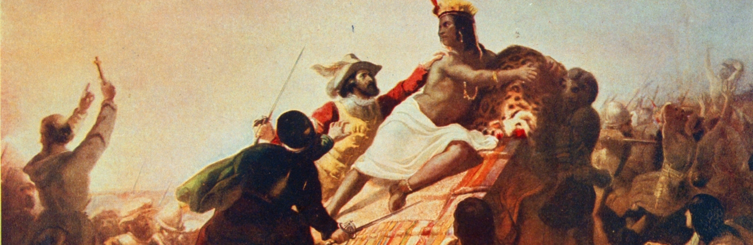
Spanish conquistador Francisco Pizarro defeats King Atahualpa
12. Describe the relationship between Francisco Pizarro and S. America.
- There was no relationship between Pizarro and S. America.
- Pizarro was responsible for conquering the Incas.
- Pizarro colonized and created a democracy granting rights to the Aztecs.
- Forming a partnership with the Natives, Pizarro was able to buy the land for the Spanish.
Overthrow of Colonial Rule
Spanish forces were not completely defeated until 1823. In 1819, however, Bolivar united Venezuela, Colombia, Panama, and Ecuador to form an independent republic called Gran Columbia. Simon Bolivar became known as the “Liberator”. He became its first president.

13. Who played an important role in leading Spanish colonies gaining their independence?
_________________________________________________________________________
Challenges in Venezuela
In 1998, Venezuelans elected a former military leader as president. The president frequently criticized the United States and became friendly with anti-U.S. governments in Cuba and Iran.
After his election, he promised to use Venezuela’s oil income to improve conditions for the country’s poor. His strong dictator-like rule split the country into two opposing groups. Working-class people supported the new president and wealthy Venezuelans opposed his policies. He died in 2013, a new leader, Nicolas Maduro, continued the policies.

14. The above passage, is referring to which influential leader?
- Simon Bolivar
- Kim Jong Un
- Hugo Chavez
- Jose de San Martin

