Name ___________________________________________________ Date ___________________ Class _____________
Unit 2 Map
Label the following countries – in ALL CAPITAL LETTERS:
N. Korea
Russia
United Kingdom
United States
Iran
Cuba
Greece
Saudi Arabia

Label (IN ALL CAPITAL LETTERS) then color each continent a different color AND place them in the key:
N. America
S. America
Australia
Asia
Antarctica
Europe
Africa

Label the following bodies of water and color blue:
Pacific Ocean
Atlantic Ocean
Arctic Ocean
Indian Ocean

Finish the key

Label the compass that is partially drawn in key.

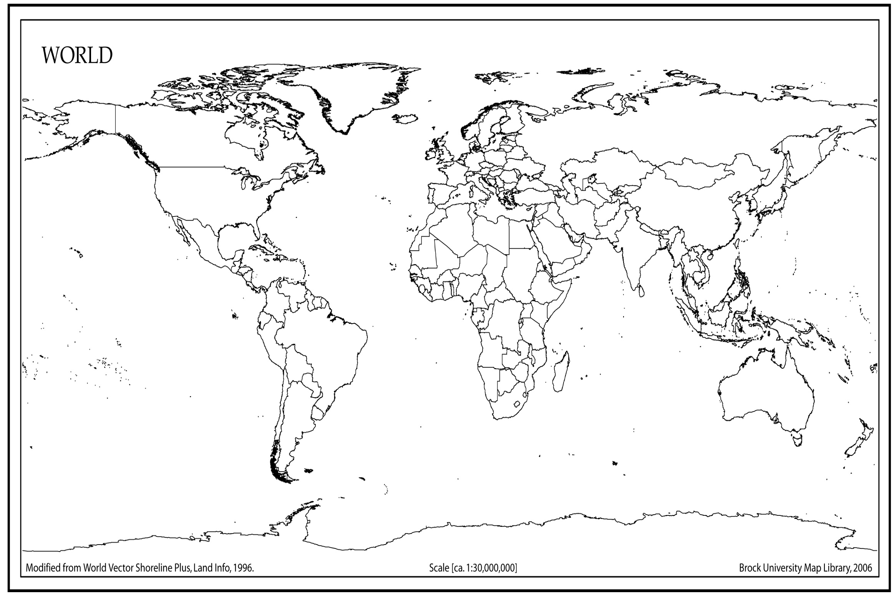
Key

Water =
N. America =
S. America =
Asia =
Africa =
Australia =
Europe =
Antarctica =

