Name: ______________________________________________ Date:_____________ Class:________

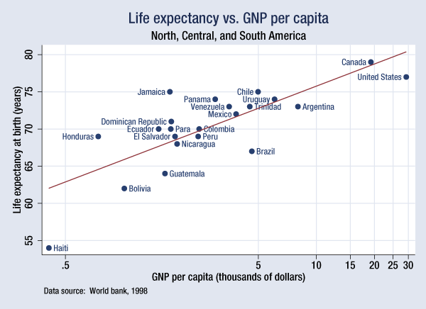
Thematic Maps Practice

1. Identify the title of this Thematic Map? _________________________________________________
2. What does GNP per capita measure?
_____________________________________________________________________________________
_____________________________________________________________________________________
3. Which country has the lowest life expectancy and GNP per capita? _________________________________________________________________________
4. Which country has the highest standard of living? Jamaica or Chile Explain.
_________________________________________________________________________
5. Describe the correlation you can make between GNP per capita and Life Expectancy.
__________________________________________________________________________________________________________________________________________________

