Mongols and Czars
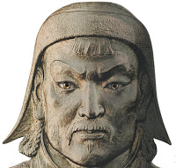
Genghis Khan was the man who united many tribes of modern day Mongolia. These nomadic tribes were united in 1206 when he claimed the title of Khan, leader of all Mongolians. The Mongolians would later create the largest land empire in the history of the world. Between the 1200’s and the mid 1400’s it is estimated that the Mongols killed around 40 million. They used the military plan of “surrender or die”—and sometimes those who surrendered would be killed to serve as an example to other people. Also, when invading an area, the Mongols would do whatever it took to conquer a town such as: diverting rivers to cut off water, block food supplies and burn farmland, kill most of the people and let some go to the next city so that they can report the destruction.
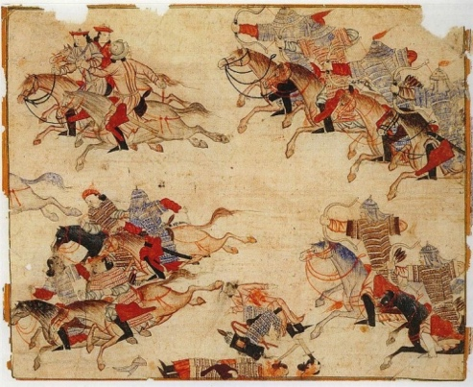
Horses were the main factor that made the Mongol army so strong. Each Mongol soldier had at least one or two horses. The primary weapon of the Mongol forces was the bow. At the time, it was unmatched for accuracy, force, and reach. It is believed that most soldiers could hit their target from nearly 100 yards—though the bow would easily fire arrows over 400 yards. So, Mongolians would “soften” the enemy from 400 yards away with thousands of wildly shot arrows coming down like rain, then charge in and finish the job once the enemy was confused and scattered.

Mongol horses were small, but their riders wore light armor and moved with great speed. The Mongolian people were nomadic herders, so they were constantly on horseback. The soldiers were men who grew up on horses and used their bow every day in hunting making them nearly as trained as professional soldiers.

Technology was one of the important parts of Mongolian warfare. Siege machines, such as catapults, siege towers, and the battering ram were an important part of Genghis Khan's warfare. The siege engines were disassembled and were carried on horses to be rebuilt at the site of the battle. Another favorite siege attack was catapulting flaming objects into a walled city or catapulting poison food for people who are starving inside the walls.

Accomplishments

While men were busy being Mongol warriors, the women kept the economy going and held some of the highest positions in their religion. This put the Mongol ladies in a position of power that their European contemporaries could only dream about. The women weren’t just happy with running the businesses and religion, either—the Mongols also had several female rulers.

Mongols were wanderers by nature, so efficient communication between their leaders and officers was both vital and extremely difficult. They solved this issue by inventing an incredibly efficient postal system called Yam (meaning “checkpoint”).
It was a vast collection of postal stations, with dedicated messengers delivering mail, intelligence reports, and important news from station to station. These stations were about 15–40 miles apart, and were kept constantly staffed.

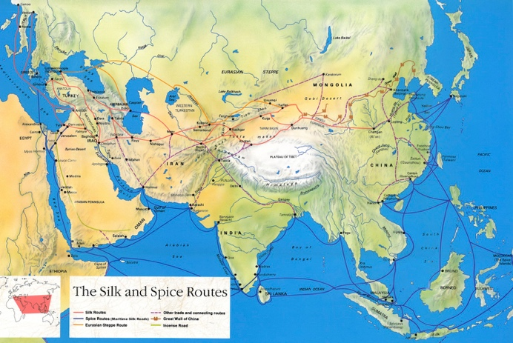
One of the most ruthless, yet efficient, parts of Genghis Khan’s reign was his brutal conquest of the Silk Road, the main trade route between Asia and Europe, and one of the largest sources of income for the Mongol empire. Conquering the trade route took quite some time but the Silk Road was entirely under Mongol control for the majority of the 14th and 15th centuries. The Mongols treated traders well and managed to not only encourage, but actually invigorate, caravan trade between the Mediterranean and China. However, passing through the Mongol-era Silk Road was not cheap: Most of the revenue its trade created went straight into the deep pockets of the Mongols, in the form of various tolls and taxes.

The Mongols decided very early on that in order to conquer a giant empire, they had to accept the habits of the people they conquered. They were happy to let their subjects keep their religion and important cultural habits and actually actively encouraged this with things like tax reductions for priests. Since Mongols themselves had a very open and relaxed attitude toward religion, this cost them practically nothing—and provided a valuable tool in keeping the conquered nations content.

Mongols to Czars

Mongol rule in Russia began to experience challenges in the late 1300s. Approximately 100 years later, Moscow was strong enough to throw of Mongol (or Tarter) Rule for good. This change ushered in the time in which Russia had a royal family. The emperor was called the tsar or czar. Czars ruled Russia from 1547 to 1917. The first Czar, Ivan the Terrible, was crowned at age 16. The first half of his reign was filled with reforms and modernization but the second half Ivan the Terrible earned his name. He grew unbalanced and violent.

Peter the Great was a czar in the late 17th century who was best known for his extensive reforms in attempt to establish Russia as a great nation. He created a strong navy, reorganized his army, created school reforms, and took greater control over the church. Catherine II, often called Catherine the Great became the Russian empress in 1762. Under her reign, she brought forth education reforms and championing the arts. As a leader, Catherine also extended the country’s borders through military might and diplomatic prowess.

Paragraph  # | Note Take  Take notes directly from the reading. | Note Make  Draw a picture, ask a question, make an inference, etc. Interact with the note take!

